Game Design Document Updated:

Racquetball

By:
Parker Hague

Blue Text = Updated

High Concept:

Elevator Pitch:
A semi-realistic racquetball arcade game with powerups, upgradeable racquets, and an AI opponent to play against. This game is perfect for people who love racquetball or those who want to enjoy a fun arcade game.

Game Type:
This is an arcade style game that will be developed for a desktop but could ideally work on a mobile device or a platform console too. This game is intended for those between ages 12 – 30. Like many arcade games, this will be one of skill that will take practice to achieve proficiency. Also, like similar games in its category, this game will consist of a bunch of a smaller game sessions where when the player wins or loses the round, they will immediately be able to try again next round. These fast-paced resets are what will make the game fun and addictive. The game could be playable with one or two players. This game will take quite a bit of skill as movement and hitting the ball take some getting used to.

Differentiators:
This game will be different than other arcade style games because I am going to try to make the game mechanics as realistic as possible to real life racquetball (except for the powerups). So, while this game will still have the fun arcade aspect, I want it to still be very similar to racquetball. On the other hand, this game will be different than racquetball mainly with the fun powerups that I am going to implement in the game. I am considering adding multiple balls to add an extra fun aspect to the game. I am still wanting to decide on this decision or not.

Features:
- Close to real world physics
- AI opponent
- in-game powerups
- upgradeable racquets stats

Unique Selling Points:
- There’s not a ton of fun sports games. They’re usually either very realistic, or very fake and “arcadey”. My game aims to bridge the gap between these two styles of games.
- This game is different in the terms of most sports games. A lot of people make soccer or basketball sports games. It’s not very common at all to find a racquetball game (let alone a fun one).
- Realistic aspect. I wanted to make this game realistic enough that the player could take the concepts from the video game and apply them to a real life racquetball game. This is mainly in regard to the physics and where the ball goes in certain situations and how the player can expect the ball to behave in real life. I am hoping to replicate the way the ball moves in real life inside the game.

Game Play:

Introduction:
This is the game of racquetball. This game has a simple story. The name of the character is one given by the user. This character has only one life goal: to play racquetball. Along the player’s journey, they’ll battle their opponent in order to collect coins and upgrade their racquets. The player gets to choose the difficulty of their opponent. A higher difficulty means more coins will be awarded at the end of the game.

In Game Competition:

AI Opponent:
The AI opponent will have varying levels of difficulty and it will be set at the start of each game. The different difficulty levels could have entirely different implementations of the AI opponent. For example, in Easy mode the opponent might just run to an area where it thinks the ball may land based on it’s trajectory. Whereas Hard mode could implement an actual AI from a neural network that makes intelligent decisions based on past games its played (through training).

Powerups:
The powerups will be objects the spawn in random places on the court and in random intervals. The powerups will include things like a magnet-racquet, letting the ball hit the ground twice, slowing down the game play, temporarily blinding the opponent, and more.

Game Mechanics

Player Controls:
The game character movement will be controlled by traditional WASD keys or the arrow keys. The plyer will hit the ball by left clicking with their mouse (hold down the button for more power) and the player will be able to aim their hit by the direction that their mouse in pointing. When they player swings, they will automatically hit the ball if they’re within a certain radius of the ball. It may be necessary to add an certain error percentage when swinging if it’s needed to increase the difficulty of the game. Ideally, this error percentage would be mitigated by upgrading the player’s racquet. As of now, I’m considering making the ball be automatically hit when the player is in range of it. This will increase the overall ease and playability of the game.

Physics:
The game will model real world physics as close as possible. For example, in real life, if I hit the racquetball at a specific spot on the back wall with a specific speed, I would expect to see the ball come off the wall at a specific speed, trajectory, and with a specific bounce. My goal is for the equivalent in-game hit to have the exact same speed, trajectory, and bounce. This way I can keep my vision of having this game be a tool for real life racquetball players.

Updated:
Creating a game with lifelike physics and ball movement is proving to be harder than I thought. I’m having to make minor changes to the real in game physics to make the game a little more playable.

Gear Selection:

Gear Viewer:
The player will be able to view all player owned racquets as well as ones not purchased yet. The racquets will each have a unique display name, look, and stats. The player’s racquet will affect things like max power, swing radius, and swing error.

Purchase Screen:
When viewing the racquets, there will be an option to purchase them if the player has enough coins.

Game Content:

Characters:
The characters will be made up capsule shapes. I will probably end up choosing the 3D pill that Unity provides. The AI opponent will be a different character color than the main character.

Powerups:
For the different powerups I will either create my own or try to find some cool 3D ones online. I will need a different one for each power.

Racquets:
Racquets can all be the same 3D asset but with different colors denoting the different racquets and ranks. The concept of racquets may end up just being replaced by an upgraded hitting radius.

Sounds and Effects:
The game will have a few songs that loop during play and while in the menu screens. I plan to have various sound effects like sounds when the racquet hits the ball and when the ball hits the wall. I will also have a sound play at the beginning and end of every round.

Setting:
Most of the time spent in the game will be in one particular location which is the racquetball court. The court will look like a typical regulation size racquetball court, a room with a wood floor, ceiling, and four walls with red service lines in the middle of the court. I’ve ditched the regulation court size and make the court smaller to help with the game’s playability.

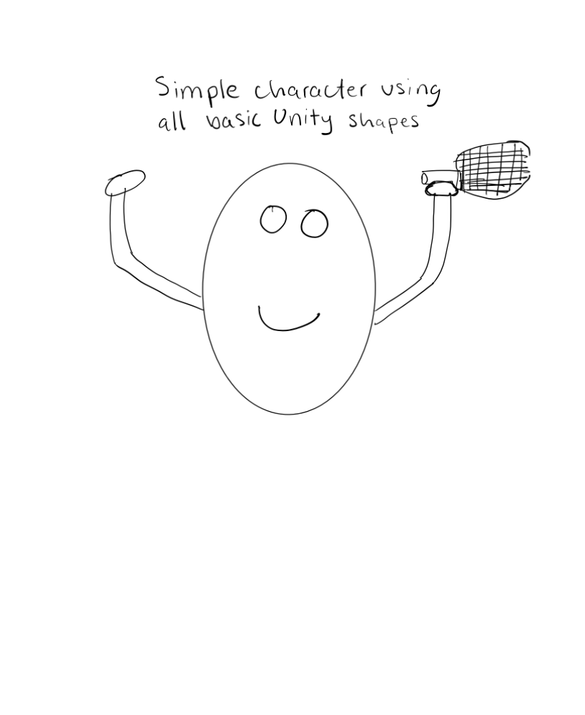
This character is super ugly on paper and will look much better once actually created.
I don’t think my players will end up having arms and racquets. The way it’s going to be implemented, the player won’t actually be swinging a racquet.

Timeline:

October 18th: I hope to have the game scene created and the court more or less finished.
Completed
October 25th: I would like to have all of the physics for the ball implemented
Almost Completed (minor issues)
November 8th: I would like to have the player movement & ball hitting functionality finished
Almost Completed (minor issues)
November 22nd: I would like to have the AI implemented with all the difficulties
November 29th: I would like to have all the sounds and effects done in the game
December 2nd: I need to have the gear selection and upgrade functionality done by this date

I gave myself about a week for each step. I gave myself two weeks for the player and AI opponent implementations since I believe those will be the more challenging parts that take longer.

The progress on the assignment has been going somewhat smoothly. I easily got the game scene setup and the court created. I’ve had a few hiccups with the movement, but overall, it seems to be working fine. Right now, my biggest struggle is finding a good way to hit the ball where I want it to go. This part is only working halfway correctly. My other main issue is that when the player is going fast enough, it goes through the collider on the court wall and the player falls through space. I do not know how the player is able to go through the collider.

